**DAILY ONLINE ACTIVITIES SUMMARY**

|  |  |  |  |  |  |  |  |  |
| --- | --- | --- | --- | --- | --- | --- | --- | --- |
| **Date:** | **04-06-2020** | | | | | **Name:** | **JAYANTH S V** | |
| **Sem & Sec** | **VIII Semester & A Section** | | | | | **USN:** | **4AL16CS041** | |
| **Online Test Summary** | | | | | | | | |
| **Subject** | | **SMS** | | | | | | |
| **Max. Marks** | | **60** | | **Score** | | | **60** | |
| **Certification Course Summary** | | | | | | | | |
| **Course** | **Introduction to Ethical Hacking** | | | | | | | |
| **Certificate Provider** | | | **Great Learning** | | **Duration** | | | **6 Hours** |
| **Coding Challenges** | | | | | | | | |
| **Problem Statement: Program to print multiplication of the table of any numbers.** | | | | | | | | |
| **Status: COMPLETED** | | | | | | | | |
| **Uploaded the report in Github** | | | | | **YES** | | | |
| **If yes Repository name** | | | | | **Jayanth-Sv** | | | |
| **Uploaded the report in slack** | | | | | **YES** | | | |

Online Test Details:

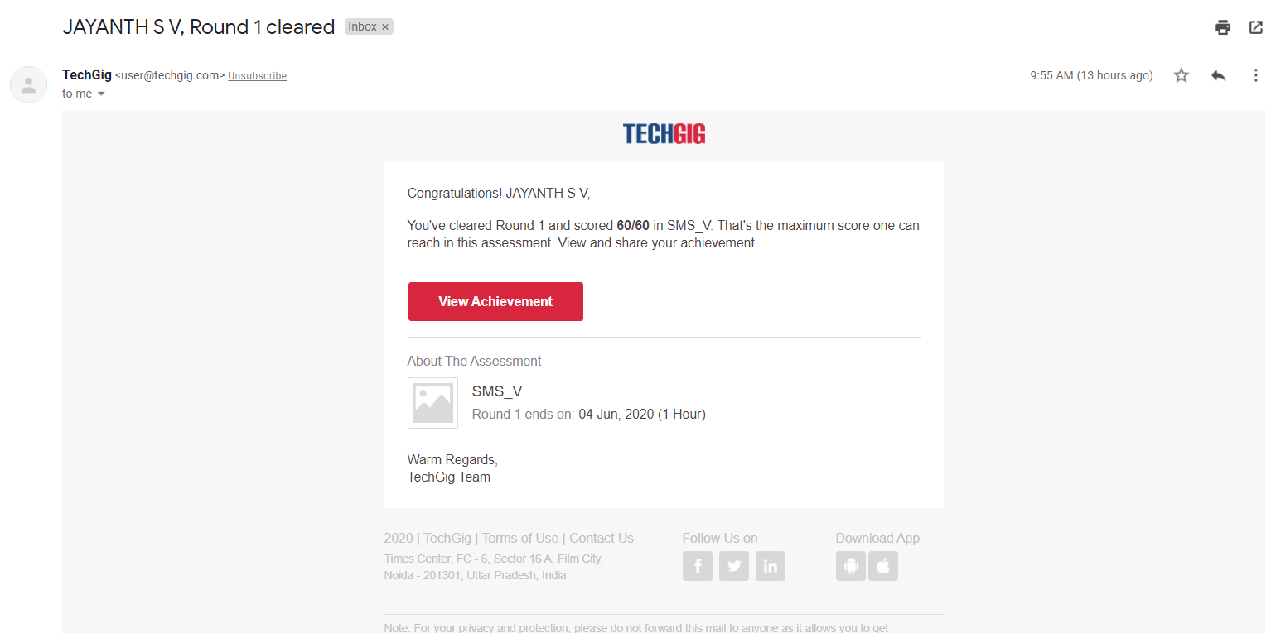

Coding Challenges Details:

|  |
| --- |
|  |
|  |
|  |
|  |
|  |
|  |
|  |
|  |
|  |
|  |
|  |
|  |
|  |
|  |
|  |
|  |
|  |
|  |
|  |
|  |
|  |
|  |
|  |
|  |
|  |
|  |
|  |
|  |
|  |
|  |
|  |
|  |
|  |
|  |
|  |
|  |
|  |
|  |
|  |
|  |
|  |
|  |
|  |
|  |
|  |
|  |
|  |
|  |
|  |
|  |
|  |
|  |
|  |
|  |

**Program1:**

**#include<stdio.h>**

**int main()**

**{**

**printf("\n\n\t\t learn\n\n\n");**

**int n,i;**

**printf("Enter an integer you need to print the table of: ");**

**scanf("%d", &n);**

**printf("\n\n\n");**

**for(i = 1; i <= 10; i++)**

**{**

**printf("\n\t\t\t%d * %d = %d \n", n, i, n*i);**

**}**

**printf("\n\n\n\n\t\t\ Fun !\n\n\n");**

**return 0;**

**}**